Probability

Samantha Redepenning
Monticello Middle School
sam.redepenning@monticello.k12.mn.us

Kristie O’Beirne
Bagley High School
kobeirne@bagley.k12.mn.us

Mandy Pula
Bagley High School
mpula@bagley.k12.mn.us

Grades 7-10

EXECUTIVE SUMMARY:

Unit 1: In this probability unit students will be exploring the differences between experimental and theoretical probabilities by simulating real-world situations. Students will understand the difference in calculating experimental and theoretical probabilities and will be able to represent the probabilities as fractions, decimals, and percent’s. Lastly, students will have an understanding of how to calculate probability as a fraction of the area while constantly making sure that all areas area evenly split before representing the probability as a fraction, decimal, and percent.

Unit 2: Students will be exploring simple, experimental, theoretical and compound probabilities through group or whole class activities. Students will be able to understand sample space, how to write probabilities in fractions and percentages along with reducing their fractions to it’s simplest form. Students will also be able to show different models (list, table, abbreviated tree and probabilistic tree) to represent probabilities. They will also understand replacement and non-replacement and how to calculate the right probabilities.

Unit 3: Students will use a list, table, tree, abbreviated tree, and probabilistic tree to organize a sample space. They will also learn about area models and how they can be used to organize a sample space.

MN STANDARDS:
Unit 1:
7.4.1.1 Design simple experiments and collect data.
7.4.3.2 Calculate probability as a fraction of a sample space or as a fraction of area. Express probabilities as percent’s, decimals, and fractions.
7.4.3.3 Use proportional reasoning to draw conclusions about and predict relative frequencies of outcomes based on probabilities.
Unit 2:
9.4.3.8 Apply probability concepts to real-world situations to make informed decisions.
9.4.3.1 Select and apply counting procedures, such as the multiplication and addition principles and tree diagrams, to determine the size of a sample space (the number of possible outcomes) and to calculate probabilities.
9.4.3.2 Calculate experimental probabilities by performing simulations or experiments involving a probability model and using relative frequencies of outcomes.
Unit 3:
9.4.3.1 Select and apply counting procedures, such as the multiplication and addition principles and tree diagrams, to determine the size of a sample space (the number of possible outcomes) and to calculate probabilities.
9.4.3.2 Calculate experimental probabilities by performing simulations or experiments involving a probability model and using relative frequencies of outcomes.
9.4.3.8 Apply probability concepts to real-world situations to make informed decisions.

TABLE OF CONTENTS:
Unit 1: Theoretical and Experimental Probability pg: 3
Day 1: Silly town of Smithville!
Day 2: I want Sugar Cereal!
Day 3: I want Sugar Cereal! (part 2)
Day 4: Calvin is back and he doesn’t like his BEDTIME!
Day 5: Probability Math Stations!
Pretest and Posttest pg: 11

Unit 2: Simple, Experimental, Theoretical and Compound Probabilities pg: 12
Day 1: Everyone is a Winner Game
Day 2: Everyone is a Winner Game (Experimental and Theoretical with replacement)
Day 3: Which Would You Rather Have? (Compound Probability with no replacement)
Day 4: Compound Probability Task Card Activity
Day 5: Probability Bingo (Simple, Experimental and Compound with simplest form fractions)
Pretest and Posttest pg: 15

Unit 3: Organizing a Sample Space pg: 16
Day 1: Marble game making a list, table, and tree
Day 2: Marble game making a abbreviated and a probabilistic tree
Day 3: Marble game making all five without replacement
Pretest and Post Test pg. 17
Day 4: Pirates Island
Day 5: Free Throw Shooting
Pretest and Post Test pg. 18

UNIT ONE ~ Theoretical and Experimental Probability

DAY 1: Silly town of Smithville!

- Students will take the first 20 minutes of class to complete the pretest that relates to this unit on Theoretical and Experimental Probability .

Launch: The Silly town of Smithville made a new rule that when a family has a child, they have to name their child using the three letters R - O - B. Little Calvin will be having a baby brother or sister born in the next month and he is interested in determining how many different names his parents have to choose from using the three letters R - O - B. In your groups, can you come up with ALL of the different name possibilities?!
HINT: There are more than 5 name possibilities but less than 10

Explore: In groups (groups of 4), students will work through finding all the different name combinations. Each group will then be asked to share what they have come up with on the board.

Share: As a class we will go through and talk about the possibilities. (there are 6 of them)
- I would like to discuss how to find this using a tree diagram and a list
  - I want the students to understand that all of the possibilities they have come up with is called the Sample Space of the data
- Lastly, I want to introduce them that this is known as the theoretical probability.
  - P(event)= favorable outcomes total number of possible outcomes (number of things in sample space)
- I would like to practice calculating some probabilities from the sample space
  - Probability of name starting with R, starting with R or O, not starting with B, etc.

Summarize: Students will have time to summarize findings from class today in their notebook. I would want them to summarize in their own words:
What is theoretical probability? What is a sample space? How do you prefer to find sample space (tree diagram or lists)?

DAY 2: I want Sugar Cereal!

Launch:
Part I: We have more work to do! The Silly town of Smithville is changing their baby naming rule AGAIN. Instead of the letters R - O - B, they are demanding people name their children using the four letters G - L - E - N.
Calvin has ANOTHER sibling on the way. In your groups:
- Write the sample space for all possible names using the letters G - L - E - N
- Calculate the following Theoretical Probabilities:
  - P(name starting with L)=
  - P(name starting with G, L, or E)=
  - P(name not starting with N)=
Groups will work, they will share their findings on the board, and we will conclude this section of the launch by discussing and taking questions.

Part II: Calvin is done worrying about his siblings, he is on his first day of Summer Break!! His mom wants him to be “healthy” this summer and is limiting the amount of sugar cereal he can eat for breakfast! Calvin wants to make a deal with his mom!! He searches through his kitchen and finds plastic cups and large marshmallows! Calvin thinks if he shakes up a cup and flips out a marshmallow that it will land on its side more than on one of the ends! Before he makes a deal with his mom “Land on Side= Sugar Cereal, Land on an End=healthy cereal” He wants to experiment and see if he is making a good deal!

Explore: In groups of 2, students will simulate this situation. Each group of 2 will do 40 trials. They will copy the table below into their notebooks and record their data using tallies in their notebook. To start, they will only make tallies in the second row (Partner Data because they are working in pairs)

 | Side | End
Partner Data (40 trials)
Entire Class

Share: I will have an excel sheet up recording data from all of the groups. Once they finish their trials, they will come up and tell me. Once I have every pairs data, I will project the numbers and get total calculations. I will instruct the entire class to fill in the final row of the table using the data from the excel.
** Tell students to keep this table in their notebooks for tomorrow ** We will analyze the data and do more with analyzing and talking about experimental probability the following day in class **
Summarize: I will tell students we will be coming back to Calvin tomorrow and will be making a decision based on the data we collected if Calvin should stick with sides for sugar cereal or switch to ends.
I will also explain that this week will be about probability and so far, we have learned about theoretical probability. Tomorrow we will dig deeper into experimental probability and learn how to express probability as a reduced fraction, percent, and decimal.
Ask students, as a “quick jot” in their notebook, where they have heard about probability and/or have used probability before?

DAY 3: I want Sugar Cereal! (part 2)

Launch: Welcome Class!! It is now the second day of summer for Calvin and he had his second day of HEALTHY cereal! He needs to purpose to his mother TODAY about the marshmallows : SIDE or END being the the winner for SUGAR cereal?!?!

** Have students turn to their data in their notebooks from yesterday
Using the class group data, I will teach students how to write the results as a reduced fraction, as a decimal, and a percent.
In their partners from yesterday, students will practice calculating the probability of their partner trials as a reduced fraction, as a decimal, and a percent.
Talk about what we did yesterday with the cup and the large marshmallow and doing trials is a different type of probability called experimental probability because we did an experiment. Talk about the class data being a better guide as to what Calvin should do because of the increased amount of trials.
Ask the students: SO, you’re all supposed to be the experts for Calvin, what should he do? Sides for sugar or ends? They will have time to discuss in groups, write decision on board, and then they will share as a whole group using data from the experiment to back up their decision.
Explore: Man, Calvin is just not sure about his chances of getting Sugar Cereal. He wants us to take one more day to be experts on the topic and to gather a different set of data. Simulate another experiment, this time with three small marshmallows. Flip the cup over 14 times and record how many sides and ends. (this will end up giving students 14*3=42 trials).
With their same partners from the day before, students will do their trials, calculate experimental probability as a reduced fraction, decimal, and as a percent. They will copy the table below in their notebooks and record their partner data in the second row.

 | Side | End | Probability as a fraction | Probability as a decimal | Probability as a percent
Partner Data (42 trials)
Entire Class

Share: As groups are finishing they will share their data with me ( I will be entering the data into an excel spreadsheet). Once all data is in, I will project it for the students. I will give them time to calculate the probability as a fraction, as a decimal, and as a percent.
I will ask partners to compare with another pair, agree on answers, and to write their answers to the fraction, decimal, and percent on the board.
In addition, I want in the groups of four, to decide if Calvin should roll the small or large marshmallow to make his cereal decision and then sides or ends.
As a class we will discuss what Calvin should do based on our data and experiment. Talk about the converting from fraction, decimal, and percent.
Lastly, review the activities we have done the past two days and remind students it is called experimental data. We set up an experiment, gathered data and made predictions as to what Calvin should do with the experimental data.

Summarize:
Discuss with students: why it is better to have more trials? How did we use an experiment to test out Calvin’s idea? What did we learn from our experiments with the small marshmallow and the larger? What was the benefit of Calvin setting up an experiment to determine what to purpose to mom?

DAY 4: Calvin is back and he doesn’t like his BEDTIME!

Launch: In groups, students will work on the following problem and post their answers on the board.
There are 3 red blocks in a bag, 4 green block, 1 blue block, and 2 yellow blocks.
1) What is the P(picking out a yellow block)= ___________ ___________ ___________
Reduced Fraction Decimal Percent

2) What is the P(picking out a yellow or green block)= __________ __________ _________
Reduced Fraction Decimal Percent

3) Calvin, from Smithville did an experiment. He did 40 trials and got red 10 times, green 18 times, blue 2 times, and yellow 10 times.
What is his experimental probability of picking out a yellow block? _______ ________ ______
Reduced Fraction Decimal Percent
What is his experimental probability of picking yellow or green? ________ _______ _______
Reduced Fraction Decimal Percent
** Answers will be written on board and we will have a whole class discussion

Calvin is a busy guy and now he is not happy with his bed time!! He wants to figure out if the spinner below gives him a good probability of going to bed later than earlier!
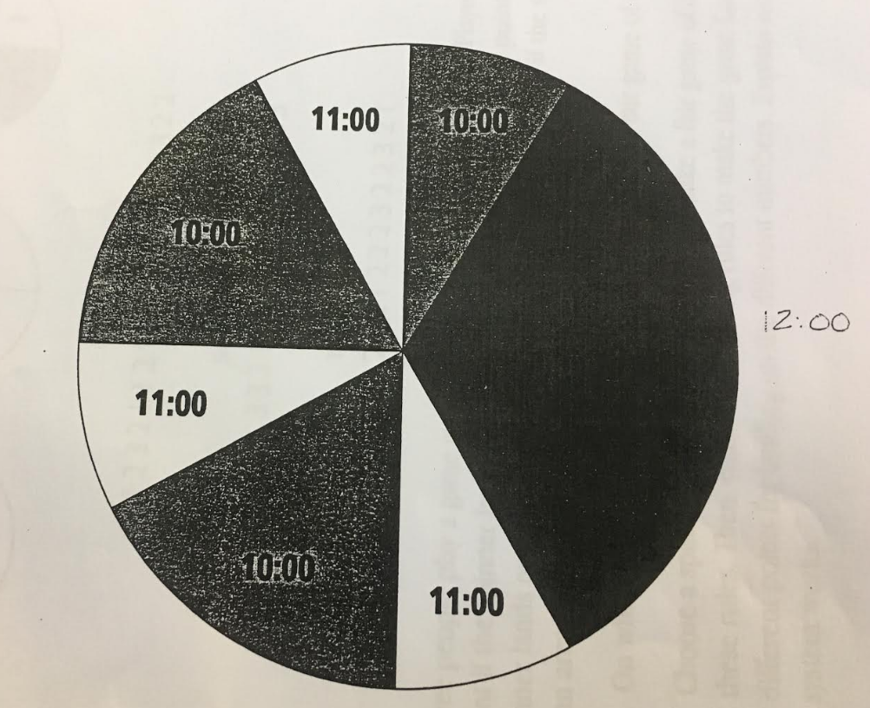

Explore: In pairs, students will do the following:
- Calculate the theoretical probabilities of each bedtime as a reduced fraction, decimal, and percent (HINT: a major part of probability is splitting sections into equal parts)
- Simulate an experiment by using a pencil and a paperclip on the spinner. Students will accurately record their data for 48 trials in their notebooks. They will need to keep track of how many times they spin, 10:00, 11:00, and 12:00
- Calculate their experimental probabilities of each bedtime as a reduced fraction, decimal, and percent
- Record Data on whiteboard (during this time I will be entering class experimental data on excel) we will talk about those results as a group too
Share: After all trials are written, ask the students to discuss in groups if Calvin has a good chance of going to bed at 12:00? At 12:00 or 11:00? Or at the earliest 10:00?
If you were Calvin, would you use this spinner if your goal was to be able to go to bed by 11:00 or 12:00 most nights of the summer? In groups, be able to explain this answer with justifications from the experimental and/or theoretical probabilities.

Have groups share on whiteboard and have a class discussion.

Summarize: In a notebook “quick jot” ask students to explain the different ways we have modeled theoretical and experimental probabilities the past two days. Explain, in their own words, the three different ways to write probability and how to do each.

DAY 5: Probability Math Stations!

- Students will take the last 15 minutes of class to complete the posttest that relates to this unit on Theoretical and Experimental Probability .

Launch: Yesterday with Calvin and his bedtime we had to make sure to split up our spinner into equal sections before calculating the theoretical probability. See if you can use that same idea with your group members today!!! Use the figure below to answer the following questions:

** Please express the probabilities as reduced fractions
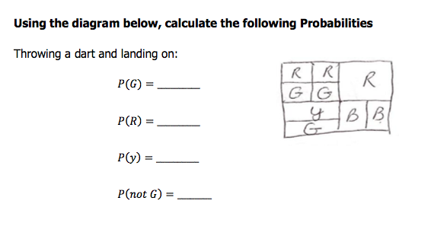
Groups will write their answers on the board. I will ask one person to come up and show how they broke apart the rectangle into equivalent pieces. We will discuss and I will take questions.
As an extension part, I will pick one of the probabilities and ask each student to convert the fraction into a decimal and percent as well.

Explore: Who doesn’t love getting up and moving?! Students will receive sheet of paper to fill out as they move station to station and to fill out as they do some experimental and theoretical probability. Students will move station to station practicing concepts related to theoretical and experimental probability.

Probability Stations Activity
Link: https://www.teacherspayteachers.com/Product/Probability-Middle-School-Math-Stations-64812
Citation:
Perro, L. (n.d) Probability: Middle School Math Stations. Retrieved June 28, 2017 from: www.teacherspayteachers.com

Share: Students will share their explanations/answers with each other towards the end of class. We will use the document camera to share and explore together

Summarize: Discuss with students, which parts of the stations was the most difficult and why? How do you know or figure out how to solve the problem?

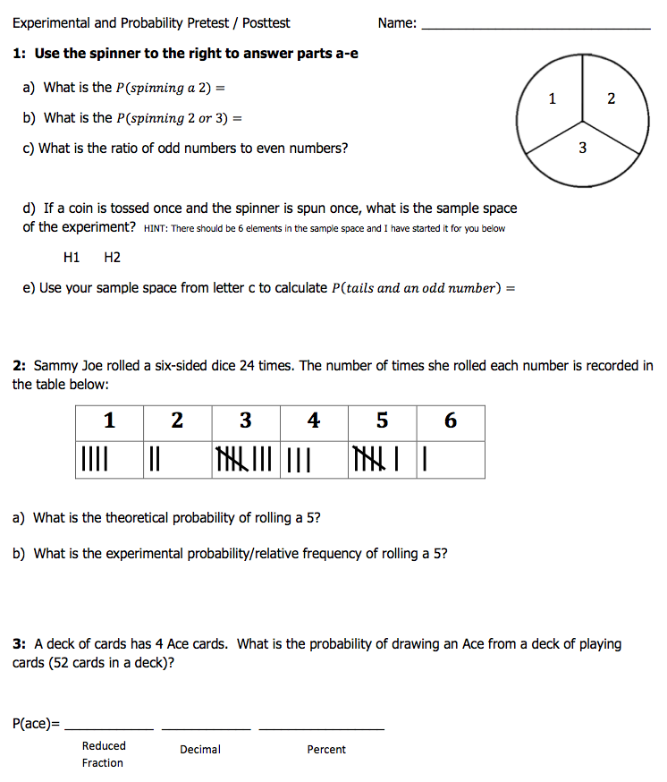

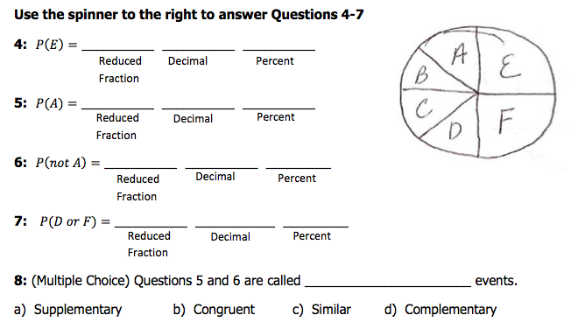

UNIT TWO ~ DAY 1: EVERYONE IS A WINNER GAME (part 1)

- Students will take about the first 15 minutes to complete the pretest on probability.

Launch: Making a lot of noise to get student’s attention announce, “Who wants to play: Everyone is a winner?” over and over until you have all students interested. Walk around the room with a can that contains 18 blocks with only three colors (blue, yellow and red). Explain to the students that their goal is to guess how many blocks of each color I have. Have students tally for winner and for loser.

Explore: Walk around room and have each student guess what color block they are going to pull out of the bag in the can before they pull the block out. Replace the block. Repeat with each student making sure every student is still tallying wins/losses and the data.

Share: Once every student has made a guess collect all the student’s data to check for accuracy and display this data on the whiteboard. Then have the students work in their groups to come up with a number of blue, yellow and red blocks.

Summarize: Ask students to explain why they picked the numbers they did. Ask the students if their numbers are accurate? How will they know when the numbers are accurate? Tell students that they will be working on probability this week. Ask students what kind of numbers are they going to be working with (fractions, decimals and percents)? Ask students where they have heard about probability before?

Assessment: Correct Pretest and collect student tally sheet.

DAY 2: EVERYONE IS A WINNER GAME (part 2)

Launch: Making lots of noise again, announce, “Everyone is a Winner, who wants to play?” Hand back students tally sheets and have them add today’s guesses/data to their yesterdays. Ask students why would we want to add to yesterday’s data?

Explore: Play the game again, making sure each student picks their color before grabbing a block. Check that all students are collecting their data.

Share: Once every student has made an attempt, have students work in their groups to come up with a number for each block. Students will need to explain why they kept their answer or why they changed their answer. Have each group write their answer on the white board and give their reasoning.
- Then talk about how to write probabilities:
  - P(event)= what makes you happy/total number.
- Experimental and Theoretical Probability
- Independent and Dependent Events
  - Replacement or not
- Have a 2nd can with blocks. Show the students how many blocks are in the can (5 blue, 8 yellow and 11 red). Have a student pull a block out. Then have students discuss in their groups what will happen next if we don’t replace the block?
P (event) = _________ * __________
- Discuss with students why this happens.

Summarize: Have students each write their answers on their tally sheet.
Discuss with students “why it is better to have more trials? How is a person to tell a simple probability from a compound probability? When does a person know if an event is dependent or independent? Lastly, how does a person know how to calculate simple or compound probabilities?

DAY 3: Which Would You Rather Have?

Launch: Show students a $10, $5 and a $1 bill. Tell the that they are going to be newspaper delivery people. Ask students what they would rather have: their boss pay them $5 per week for 30 weeks guaranteed OR have a chance to pull money from a bag that consists of ONE-$10 bill and FIVE-$1 bills from a bag once a week for 30 weeks. Clearly state the rules to the students. If they choose to pull money from the bag, whatever they choose first does not get replaced. Have students write their answer down on their paper.

Explore: Students will simulate this experiment by pulling play money from a bag. Students will accurately record their data for 30 trials. Each student in the group will try the experiment so each group should have a total of 90 trials.
Share: Have students write their results on the whiteboard. After all trials are written, ask the students to discuss in their groups if they want to keep their original answer or change it and why? Is this a fair or not?
- Theoretical Probability (different ways to model: list, table, trees, area model)
- Given three die: Roll all die and find the probability the sum of the three die are odd/even and then the product will be odd/even. Have two groups make a list, two groups make a table, two groups make a tree finding the probabilities.
- Use CPMP tools to simulate the experiment 1000 times, 10000 times, 1000000 times

Summarize: Discuss the different models and do they work on simple or compound probabilities or both? Which model works best for you? Why would we want to simulate an experiment so many times?

DAY 4: Compound Probability Task Card Activity

- Check prior knowledge on prime/composite numbers, a perfect square, quadrilaterals at beginning of class!

Compound Probability Task Card Activity
https://www.teacherspayteachers.com/Product/Compound-Probability-Task-Cards-1329560

Launch: Have students group themselves in pairs. Hand each student a recording sheet to complete their work on. Then randomly hand out the 20 different task cards around the room for each student to complete in their group.

Explore: Students will go to all 20 different stations to complete the different compound probability task cards.

Share: Students will share their explanations/answers with each other.

Summarize: Ask students which task cards were the most difficult and why? Have students turn in recording sheets.

DAY 5: Probability Bingo

- Students will take about the first 15 minutes to complete the post test on probability.

Probability Bingo Activity
https://www.teacherspayteachers.com/Product/Probability-Simple-and-Compound-Bingo-1147236

Launch: Who doesn’t love BINGO? Students will receive a bingo card and 25 beans to cover their answers on their cards with. Group students into pairs and hand out one bingo card to each pair and a student worksheet. Students must show all work and do not blurt out answers. For extra practice, the answers are in simplest terms.

Explore: Place question on projector and or connect the interactive game. Students will answer the questions on their worksheet and then place a bean on the correct answer. First group to get 5 in a row (diagonally, vertically or horizontally) wins!

Share: Students will share their explanations/answers with each other.

Summarize: Discuss with students, which card was the most difficult and why? How do you know how to solve the problem? Did you model the questions?

NAME:_______________________________
What do I know about probability? (Pre and Post Test)

1. In a concealed bag, there are 5 red blocks, 7 blue blocks and 3 yellow blocks. You reach into the bag and pull out one block. What is the probability that you pulled out a yellow block?

2. In a concealed bag, there are 5 red blocks, 7 blue blocks and 3 yellow blocks. This time you reach into the bag twice. You do not replace the first block. What is the probability that you pull out a red block and then a yellow block?

3. State the probabilities for each color on the spinner below and then state what the probability of landing on a yellow and a green is?
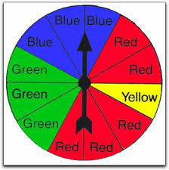

4. You have two six sided die. You roll both die. What is the probability that you rolled an even sum? Make a model to represent your data and probabilities.

5. The spinner below is spun twice. What is the probability of getting an even number followed by a number less than six?

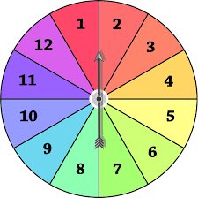

UNIT THREE ~ Organizing a Sample Space

Day 1 Marble game making a list, table, and tree

Pretest

Objective: We will analyze different ways to display a sample space for a given event. Today we will be focusing on lists, tables, and trees.

Launch: My nephew and I like to play a game. I have a bag with six marbles; 1 red, 2 white, and 3 blue. If he draws two marbles of the same color he gets a piece of candy if the two marbles he draws are different colors then I get a piece of candy. He was try to figure out if this was a fair game. Could you help him?

Explore: In groups students will explore ways to solve this problem. Hopefully at least three different groups will come up with a list, table, and tree.

Share: I will have groups come up to the board and explain the way they solved this problem. I will pick groups to share in a particular order. First the group that made a list (if there is one), then the group that made a table (if there is one), then the group that made a tree (if there is one).

Summarize: Today we learned three different ways to represent a sample space. Tomorrow I will show you two more.

Day 2: Marble game making an abbreviated and a probabilistic tree

Objective: Students will learn how to make an abbreviated tree and a probabilistic tree.

Launch: Yesterday we analyzed the marble game my nephew and I like to play. We found out that it was not very fair. We learned how to represent a sample space using a list, table, and tree. All three of these are great. Today I want to focus mainly on the tree. What were some issues that could come up with a tree? (students should reply that it is messy). I will show them how to make an abbreviated tree or if someone in class did it they can show how it is done. Next I will move into a probabilistic tree and how that would be done.

Summarize: I know I did a lot of talking today and this seems confusing. Tomorrow you will get the chance to work with both of these new methods.

Day 3: Marble game making all five without replacement

Objective: Students will work in groups to mast all five representations of a sample space.

Launch: I told my nephew about about your results and he said he did not want to play this game with me anymore. I asked him if there was any way we could make it more fair because I really like to play this game. He suggested that maybe if we did not put the marble back from our first draw maybe it would be more fair. He is only 11 so he needs your help to figure out if this would work for him. In your groups I would like you to use all five representations to solve this problem.

Explore: Students will work in groups to make a list, table, tree, abbreviated tree, and probabilistic tree. Each group will hand in their work.

Share: So will our new game be more fair? Have groups explain why or why not.

Post Test: I will give the same test I gave as a pretest on day 1 for students to work on individually.

Summarize: We have learned five different ways to represent a sample space. Over the next couple of days we will learn and practice one more method.

Pretest/Post test: Students will individually complete the following two questions.

- How many different ways are there to represent a sample space? Name them.

- Pick one way to represent the sample space for a spinner with 5 equal parts if you have to spin it twice.
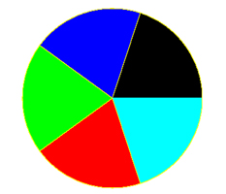

Day 4: Pirates Island

Pretest

Objective: Students will learn about area models.

Launch: You are a pirate with a treasure on your boat. You are coming into this island with two caves. You need to work with your fellow pirates and decide which cave is the safest to hide your treasure in. When you are done put your work and answer on the board.

Explore: In groups student will be given a map of an island and need to decide if Cave A or Cave B is a better hiding spot for their treasure. Groups will put how they did it and their answer on the board.

Share: Groups will put how they did it and their answer on the board.

Instruct: I will show them how I solved the problem with an area model.

Explore: In groups students will get another island and again have to decide which cave to put their treasure in, but this time they must use an area model.

Share: Groups will put how they did it and their answer on the board.

Summarize: Today we started to talk about area models tomorrow we will continue to explore this topic.

Day 5: Free Throw Shooting

Objective: Students will continue to analyze area models.

Launch: In high school I played basketball. I wasn’t a very good shooter and particularly I was not a very good free throw shooter. I was about a 50% free throw shooter. My coach was always yelling at me to practice more so I could get better. I created an area model to show the probability of me making some points for my team on the free throw line. (I will create my area model for my percentage and show the students about how many points I would make per trip to the free throw line).

Explore: In groups students will figure out more problems like these using a 60%, 40%, 20%, and 80% free throw shooter.

Share: Students will share their results with the class.

Summarize: Now next time your coach yells at you for only being a 50% free throw shooter you can tell him that you make one point every time you’re at the line for two shots which is pretty good.

Pretest and Post Test:

Students will individually complete the following question.

- There are three women: Ali, Beverly, and Clara. I know they each have two children. I do not know what gender their two kids are. What is the probability each woman has two boys given the following
- Ali P(2Boys)
- Beverly P(2Boys/if I know her first kid is a boy)
-Clara P(2Boys/if i know one of her kids is a boy)

